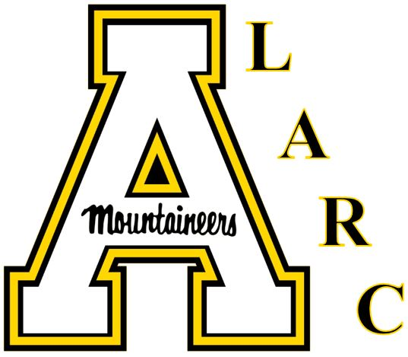
YEAR 1

Fall 2017
Gather data from faculty & students regarding future form & function of the LARC. Launch LARC website and begin to disseminate teacher and learner resources through growing bank of online resource modules. Offer 1 face-to-face workshop for faculty and 1 face-to-face workshop for students.

Spring 2018
Form ad hoc committee to assist in the interpretation of the data and develop a 2 year strategic plan based on findings. Identify core initiatives from data and focus on 1-2 initiatives to work on during the term and over the summer. Initiatives may include things like professional development, assessment, computer assisted language learning (CALL) and teaching support, coordination of conversation labs, special programming, innovative programs, or others.

YEAR 2

Fall 2018
Add 1-2 core initiatives and continue to develop existing initiatives. Begin to identify external and internal sources of funding. Form faculty advisory committee for the center.

Spring 2019
Core initiatives should be in full operation by this point. Can add secondary initiatives as resources allow. Apply for internal/external funding if any of the initiatives require financial support.

YEAR 3

Fall 2019
Continued support for primary and secondary initiatives. Consider bringing in external reviewer for early review of the converted center to gain insight for the next three years.

Spring 2020
Gather data from faculty and students again and assess current form & functions of the LARC. Combine this feedback with external reviewer and develop strategic plan for the next three years of the center.

